Decentralized Cluster-Based NoSQL DB System

## Overview:

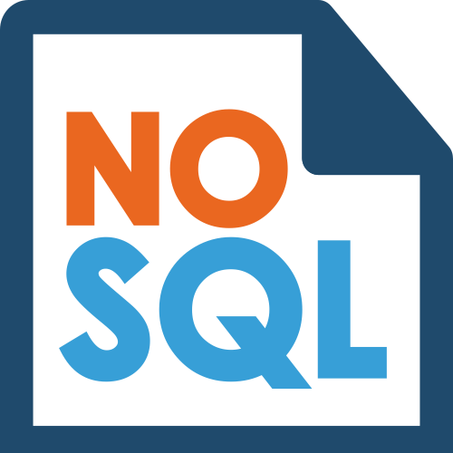

A NoSQL database (DB) is a database that stores data differently from traditional relational DB systems. Thus, NoSQL DBs provide their own APIs for performing queries, instead of using SQL. A cluster-based NoSQL DB is a collection of nodes that can service multiple users, where each node has a replica of the DB. NoSQL DB clusters can have a manager node that works as a central point in the system. We refer to such systems as centralized systems. On the other hand, NoSQL DB systems can be decentralized, where there is no manager node, and instead the nodes in the DB rely on sophisticated schemes for ensuring data consistency and load balance. In this project, I am using Java to build an application that simulates the interaction between users and nodes inside a decentralized NoSQL DB cluster. Below, I will first present the diagrams to make everything clear.

## Diagrams:

#### Sequence Diagram for user login and query handling:

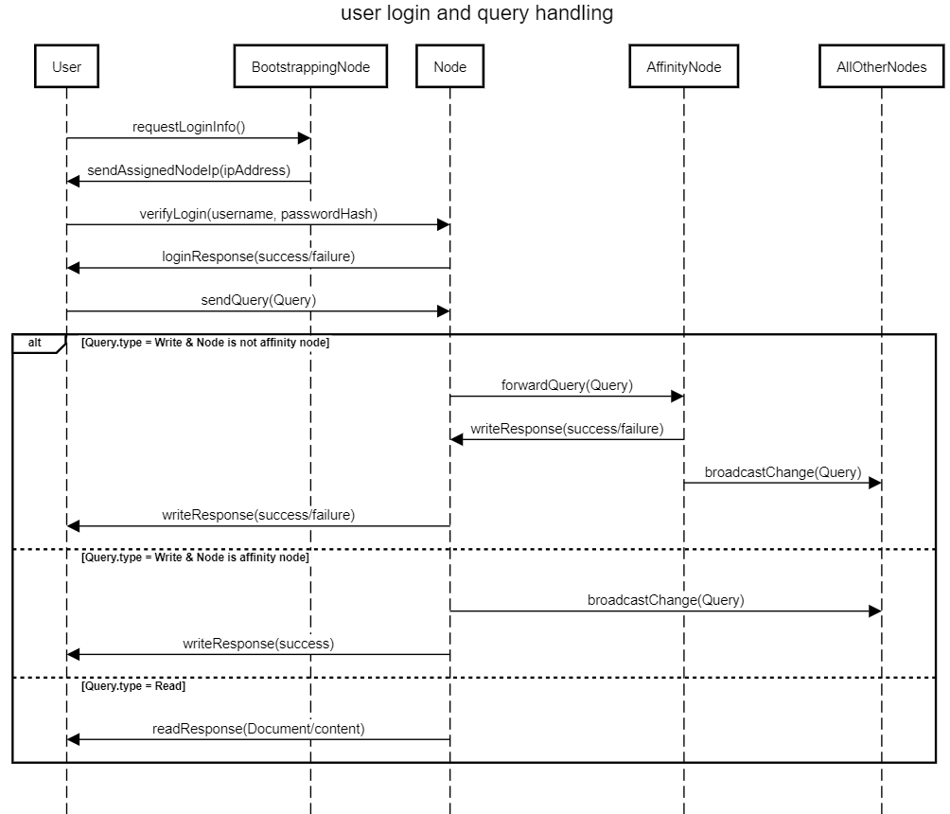

#### Sequence Diagram for data replication:

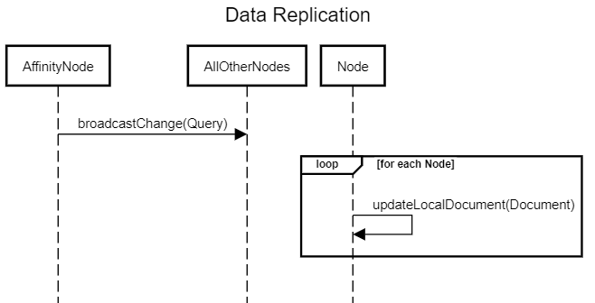

#### UML Diagram for the app:

